**GANPAT UNIVERSITY**

**U. V. PATEL COLLEGE OF ENGINEERING**

**B.Tech CE/IT Semester IV**

**2CEIT404: Python Programming**

**Practical-10: Python GUI using tkinter**

1. Write a Python GUI program to create a simple calculator.

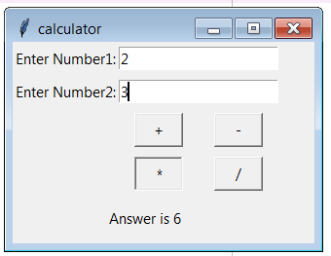

**Code:**

from ctypes.wintypes import HANDLE

from tkinter import*

top= Tk()

top.geometry("400x200")

top.title("Calculator")

*def* sum(*op*):

    n1=int(e1.get())

    n2=int(e2.get())

    if(*op*=='+'):

        ans=n1+n2

    elif(*op*=='-'):

        ans=n1-n2

    elif(*op*=='*'):

        ans=n1*n2

    elif(*op*=='/'):

        ans=n1/n2

    ans = "Answer is:"+str(ans)

    l1.config(*text*=ans)

first = Label(top,*text*="Enter Number1:").grid(*row*=0,*column*=0)

e1 = Entry(top)

e1.grid(*row*=0,*column*=1,*columnspan*=2)

second = Label(top,*text*="Enter Number2:").grid(*row*=1,*column*=0)

e2 = Entry(top)

e2.grid(*row*=1,*column*=1,*columnspan*=2)

first_button = Button(top,*text*="+",*cursor*="circle",*foreground*="Black",*background*="red",*width*=5,*command*=*lambda*:sum('+')).grid(*row*=2,*column*=1,*pady*=5)

second_button = Button(top,*text*="-",*foreground*="Black",*background*="red",*width*=5,*command*=*lambda*:sum('-')).grid(*row*=2,*column*=2,*pady*=5)

third_button = Button(top,*text*="*",*foreground*="Black",*background*="red",*width*=5,*command*=*lambda*:sum('*')).grid(*row*=4,*column*=1,*pady*=5)

four_button = Button(top,*text*="/",*foreground*="Black",*background*="red",*width*=5, *command*=*lambda*:sum('/')).grid(*row*=4,*column*=2,*pady*=5)

l1= Label(top)

l1.grid(*row*=5,*column*=1,*columnspan*=2)

top.mainloop()

**Output:**

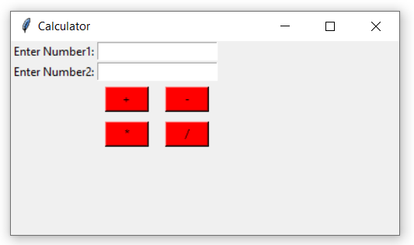

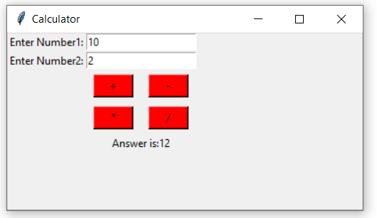

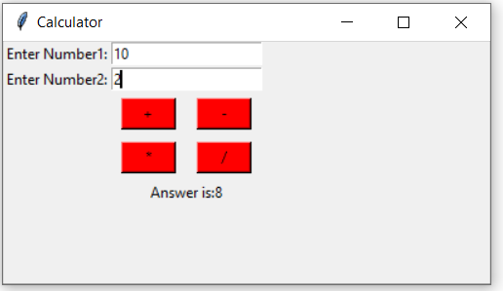

2.Make weight conversion GUI from kg to gram, pound and ounce using tkinter.

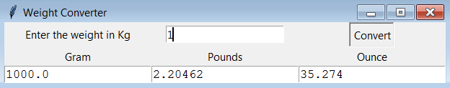

**Code:**

from tkinter import*

top = Tk()

top.configure(*bg*="Aqua")

top.geometry("500x500")

*def* from_kg():

    gram=float(e1.get())*1000

    pounds=float(e1.get())*2.20463

    ounce=float(e1.get())*35.273

    e2.delete("1.0",END)

    e2.insert(END,gram)

    e3.delete("1.0",END)

    e3.insert(END,pounds)

    e4.delete("1.0",END)

    e4.insert(END,ounce)

first =Label(top,*text*="Enter the wieght in KG")

first.grid(*row*=0,*column*=0)

e1=Entry(top)

e1 = Entry(top,*textvariable*=e1)

e1.grid(*row*=0,*column*=1)

convert = Button(top,*text*="Convert",*width*=10,*command*=from_kg)

convert.grid(*row*=0,*column*=2,*padx*=50)

second =Label(top,*text*="Gram")

second.grid(*row*=1,*column*=0)

third = Label(top,*text*="Pound",*width*=5)

third.grid(*row*=1,*column*=1)

four = Label(top,*text*="ounce",*width*=5)

four.grid(*row*=1,*column*=2)

e2 =Text(top,*height*=1,*width*=20)

e2.grid(*row*=2,*column*=0)

e3 =Text(top,*height*=1,*width*=20)

e3.grid(*row*=2,*column*=1)

e4 =Text(top,*height*=1,*width*=20)

e4.grid(*row*=2,*column*=2)

top.mainloop()

**Output:**

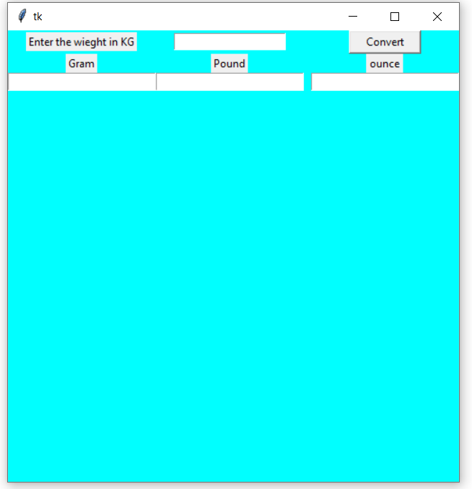

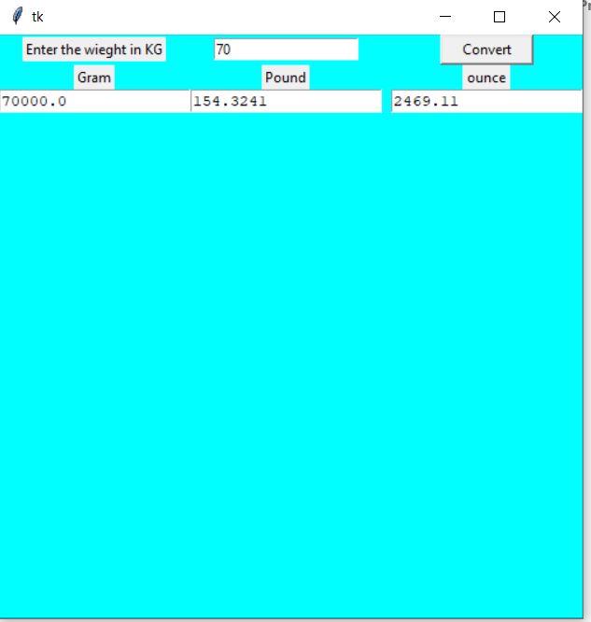

3.Write python GUI to make font menu.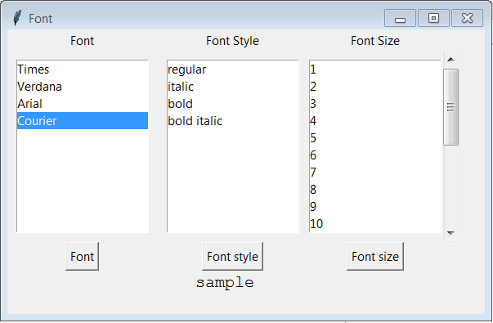

**Code:**

from tkinter import *

top=Tk()

top.title('Font')

top.geometry('500x400')

font=StringVar()

*def* font_change():

    f=Lfont.get(ACTIVE)

    l4.config(*font*=(f,))

*def* fontSize():

    fsize=fontsize.get(ACTIVE)

    l4.config(*font*=('',fsize,))

*def* fontStyle():

    fsize=fontsize.get(ANCHOR)

    fstyle=fontstyle.get(ACTIVE)

    l4.config(*font*=(' ',fsize,fstyle))

l1=Label(top,*text*='Font',*font*=('bold',12))

l1.place(*x*=50,*y*=10)

l2=Label(top,*text*='Font Style',*font*=('bold',12))

l2.place(*x*=190,*y*=10)

l3=Label(top,*text*='Font Size',*font*=('bold',12))

l3.place(*x*=350,*y*=10)

Lfont=Listbox(top)

Lfont.insert(0,'Times')

Lfont.insert(1,'Verdana')

Lfont.insert(2,'Arial')

Lfont.insert(3,'Courier')

Lfont.place(*x*=10,*y*=40)

fontstyle=Listbox(top)

fontstyle.insert(0,'regular')

fontstyle.insert(1,'italic')

fontstyle.insert(2,'bold')

fontstyle.insert(3,'bold italic')

fontstyle.place(*x*=165,*y*=40)

fontsize=Listbox(top)

for i in range(0,150):

   fontsize.insert(i,str(i+1))

   fontsize.place(*x*=320,*y*=40)

s=Scrollbar(top,*orient*='vertical')

s.place(*x*=445,*y*=40,*height*=165)

fontsize.config(*yscrollcommand*=s.set)

s.config(*command*=fontsize.yview)

s.set(0,0)

l4=Label(top,*text*='Simple')

l4.place(*x*=200,*y*=300)

b1=Button(top,*text*='Font',*font*=('bold',12),*command*=font_change)

b1.place(*x*=50,*y*=220)

b2=Button(top,*text*='Font =Style',*font*=('bold',12),*command*=fontStyle)

b2.place(*x*=185,*y*=220)

b3=Button(top,*text*='Font Size',*font*=('bold',12),*command*=fontSize)

b3.place(*x*=345,*y*=220)

top.mainloop()

**Output:**

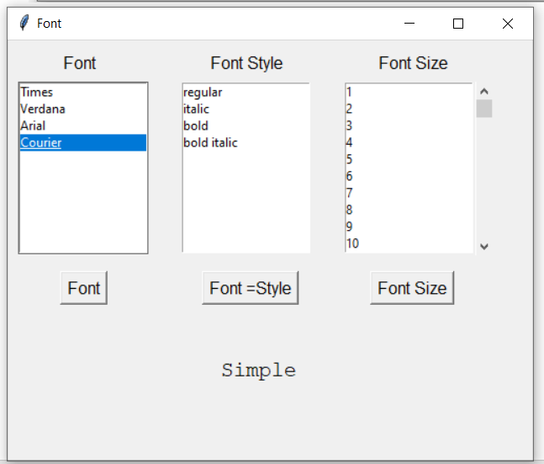

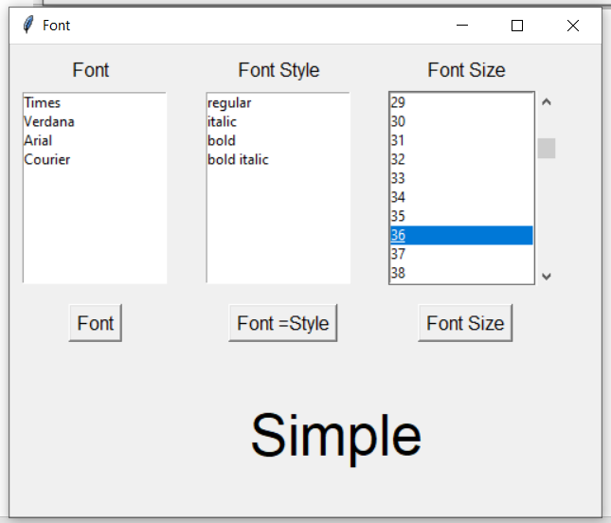

4.Create a student registration page with enrollment, name, gender, address, branch name, mobile number and email address fields and store all data in the database.

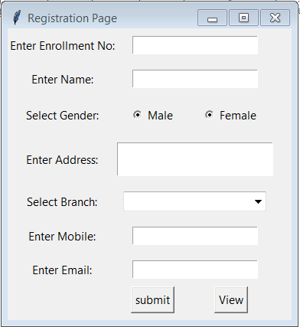

**Code:**

from tkinter import *

import sqlite3

root = Tk()

root.geometry('510x510')

root.title("Registration Form")

root.config(*bg*='aqua')

name = StringVar()

en = StringVar()

var = IntVar()

var1 = IntVar()

Email = StringVar()

mob = StringVar()

branch = StringVar()

add=StringVar()

*def* database():

 name1 = name.get()

 enr = en.get()

 gend = var.get()

 br = branch.get()

 m = mob.get()

 e = Email.get()

 ad=add.get()

 conn = sqlite3.connect('Form1.db')

 with conn:

   cursor = conn.cursor()

   cursor.execute('CREATE TABLE IF NOT EXISTS Student (Enrollment TEXT,Name TEXT,Gender Text,Branch TEXT,Mobile TEXT,Email TEXT,Address TEXT)')

   cursor.execute('INSERT INTO Student (Enrollment,Name,Gender,Branch,Mobile,Email,Address) VALUES(?,?,?,?,?,?,?)',

( enr,name1, gend,br,m,e,ad))

   conn.commit()

label_0 = Label(root, *text*="Registration form", *width*=20, *font*=("bold", 20))

label_0.place(*x*=80, *y*=53)

label_1 = Label(root, *text*="Enter Enrolment No:", *width*=20, *font*=("bold",

10))

label_1.place(*x*=68, *y*=130)

entry_1 = Entry(root, *textvar*=en)

entry_1.place(*x*=240, *y*=130)

label_2 = Label(root, *text*="Enter Name:", *width*=20, *font*=("bold", 10))

label_2.place(*x*=68, *y*=180)

entry_2 = Entry(root, *textvar*=name)

entry_2.place(*x*=240, *y*=180)

label_3 = Label(root, *text*="Select Gender", *width*=20, *font*=("bold", 10))

label_3.place(*x*=68, *y*=230)

Radiobutton(root, *text*="Male", *padx*=5, *variable*=var, *value*=1).place(*x*=240,

*y*=230)

Radiobutton(root, *text*="Female", *padx*=20, *variable*=var, *value*=2).place(*x*=295,

*y*=230)

label_4 = Label(root, *text*="Branch", *width*=20, *font*=("bold", 10))

label_4.place(*x*=70, *y*=280)

op = ['--Select Branch--','Computer Engineering','Information Technology']

branch.set(op[0])

w = OptionMenu(root, branch, *op)

w.place(*x* = 240,*y* = 280)

label_5 = Label(root, *text*="Mobile", *width*=20, *font*=("bold", 10))

label_5.place(*x*=70, *y*=330)

entry_2 = Entry(root, *textvar*=mob)

entry_2.place(*x*=240, *y*=330)

label_6 = Label(root, *text*="Email", *width*=20, *font*=("bold", 10))

label_6.place(*x*=70, *y*=380)

entry_2 = Entry(root, *textvar*=Email)

entry_2.place(*x*=240, *y*=380)

label_7 = Label(root, *text*="Enter Address", *width*=20, *font*=("bold", 10))

label_7.place(*x*=70, *y*=430)

entry_2 = Entry(root, *textvar*=add)

entry_2.place(*x*=240, *y*=420,*height*=50,*width*=125)

Button(root, *text*='Submit',*width*=20,*command*=database).place(*x*=180, *y*=480)

root.mainloop()

